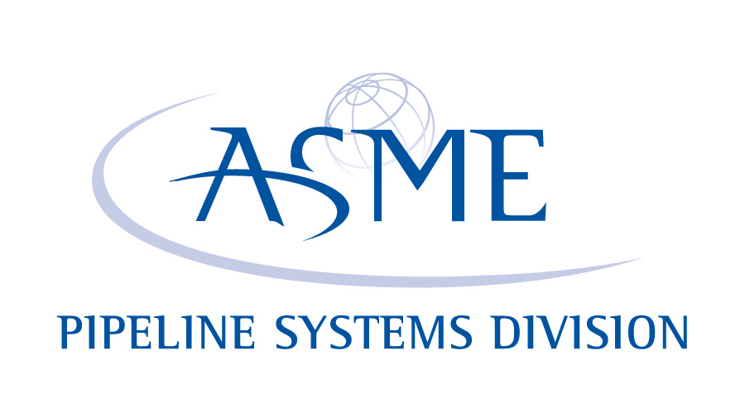

GLOBAL PIPELINE AWARD (GPA)

OFFICIAL ENTRY FORM

Submission Deadline: 1 August
The GPA recognizes the pipeline technology innovation process in all phases; from the research laboratory through field applications; from technology incubators to development of markets for new products; from government agencies to private companies; and from individual projects to the consolidation of research and development results. The PSD intends that the Award promotes progress and international cooperation in the field of Pipeline Systems engineering; supports achievements in pipeline engineering education; encourages the timely exchange of information among researchers and engineers; promotes technical activities, including conferences, in the field of Pipeline Technology; promotes safety and the public welfare; promotes global environment preservation; and promotes public recognition of the pipeline industry.

1. Name of the project, product, device, system, approach, service or other

2. Contact information. Include complete name, address (full), telephone number, email and website.

3. When was the project, product, device, system, approach, service or other introduced?

4. Was this project, product, device, system, approach, service or other previously described in any publication?

5. If the project, product, device, system, approach, service or other can be patented, has it and where?

Patent No. Patent applied for and Serial No.

6. What led to the implementation of the project, product, device, system, approach, service or other?

7. Where appropriate, describe the design/development solution to the problem.
(Include documentation, links to websites, videos, drawings that can be sent electronically that show what was done. Judges may reject designs they do not understand because of inadequate descriptive accompaniment.)

8. Describe the how this project, product, device, system, approach, service or other is a unique innovation in pipeline systems.

9. What benefits to the industry were realized through this project, product, device, system, approach, service or other?

10. Submitted by: Main Contact

Company

Mailing Address

City State Zip

Telephone: (______) ______________________ Fax: (_____) _________________________

E-Mail:_____________________________________

**Finalists will be expected to submit a 90 second video (mp4 format) file describing their entry. The winner’s video will be shown during the awards ceremony at the International Pipeline Conference (even years) or the Rio Pipeline Conference (odd years). Finalist videos may or may not be shown due to time constraints. The judging panel will view all videos.**

Entries should be submitted using the following online drop box with cc to micelik@asme.org :
https://www.hightail.com/u/ASME-IPTI

If you have any questions or problems with upload please contact Kim Miceli (micelik@asme.org).

The submission deadline is 1 August of each year.

